Algoritmos Genéticos na Otimização Combinatória: Uma Abordagem Evolutiva
Marcelo de M. Fonseca Jr.1
Universidade Presbiteriana Mackenzie
¹ Pós-Graduação em Engenharia Elétrica e Computação, São Paulo, SP – Brazil
72356741@mackenzista.com.br

Abstract. The abstract should summarize the contents of the paper in short terms, i.e. 15-250 words.
Keywords: Genetic Algorithm, Pokémon, Evolution, Crossover, Mutation, Population, Natural Selection, Combinatory, Optimization.

- Introduction
Introdução (contendo a descrição do problema a ser tratado, trabalhos relacionados e breve fundamentação da técnica a ser utilizada);

Na busca por soluções eficientes para desafios complexos em áreas que variam desde a engenharia de produção até a logística, os Algoritmos Genéticos emergiram como uma ferramenta poderosa e versátil. Inspirados pelo processo de evolução natural, esses algoritmos têm sido amplamente aplicados na resolução de problemas de otimização combinatória, nos quais a busca pelas melhores soluções deve considerar um vasto espaço de combinações possíveis.

Este artigo explora o mundo fascinante dos Algoritmos Genéticos e seu papel crucial na resolução de problemas combinatórios complexos. Ao combinar conceitos da biologia evolutiva com técnicas de computação, esses algoritmos têm demonstrado sua capacidade de encontrar soluções de alta qualidade em uma ampla variedade de cenários práticos.

Ao longo deste artigo, examinaremos a base teórica dos Algoritmos Genéticos, suas principais componentes e operadores, bem como seu funcionamento em problemas reais. Além disso, apresentaremos estudos de caso que destacam a aplicação bem-sucedida desses algoritmos em problemas como o Problema da Mochila, o Roteamento de Veículos, e muito mais.

Nosso objetivo é fornecer aos leitores uma compreensão sólida dos Algoritmos Genéticos e suas capacidades na otimização combinatória. À medida que mergulhamos nesse domínio empolgante, torna-se evidente que a simulação da evolução pode ser uma ferramenta inestimável para enfrentar desafios complexos, fornecendo soluções que se aproximam da eficiência encontrada na natureza.

- Genetic Algorithm
Optimization Problems: Genetic algorithms are frequently used to find optimal or near-optimal solutions for complex optimization problems. This can include problems in engineering, logistics, finance, and scheduling.

Robotics: Genetic algorithms can help in evolving control strategies and behaviors for robots in various environments.

Scheduling: Genetic algorithms can optimize scheduling problems in manufacturing, transportation, and project management.

Vehicle Routing: Optimizing delivery routes for transportation companies to minimize costs and delivery times.

Entre outros

  - Advantages of Genetic Algorithms:

Global Search: GAs are good at finding solutions in a large search space. They can explore a wide range of potential solutions and are less likely to get stuck in local optima.

Parallelism: Genetic algorithms are inherently parallel, which makes them suitable for parallel and distributed computing environments.

No Derivative Information: Unlike some other optimization methods, GAs do not require derivative information, which can be beneficial when dealing with non-differentiable or black-box functions.

Versatility: GAs are versatile and can be applied to a wide range of problems, including optimization, machine learning, and rule discovery, among others.

Adaptability: GAs can adapt to changing environments or problem spaces. They can continue to search for solutions even as the problem evolves.

Robustness: GAs can handle noisy or imperfect data and still converge to reasonable solutions.

Feature Selection: GAs can be used for feature selection in machine learning, helping to identify relevant features and reduce dimensionality.

  - Disadvantages of Genetic Algorithms:

Computational Intensity: Genetic algorithms can be computationally expensive, especially when dealing with large populations or high-dimensional search spaces.

Parameter Sensitivity: The performance of GAs can be sensitive to various parameters, including population size, mutation rate, and crossover rate. Tuning these parameters can be challenging.

Premature Convergence: GAs may converge to suboptimal solutions prematurely if the parameters are not properly set, or if the selection pressure is too high.

Representation Issues: Choosing an appropriate representation for the problem can be challenging, and the choice can greatly affect the performance of the algorithm.

Difficulty in Complex Constraints: Handling complex constraints in optimization problems can be challenging with GAs.

Lack of Guarantees: GAs do not provide guarantees of finding the global optimum, and the quality of the solutions found can vary.

Limited Problem Understanding: GAs are often considered as "black-box" optimizers, and they may not provide insights into the underlying problem structure.

Time-Consuming for Large Search Spaces: GAs may require a significant amount of time to explore large search spaces thoroughly.

In summary, genetic algorithms are a powerful optimization technique, but they are not a one-size-fits-all solution. They excel in global optimization and can handle complex problems, but their performance depends on parameter tuning and problem representation. It's essential to carefully consider the specific characteristics of the problem at hand when deciding whether to use genetic algorithms or another optimization method.

Crossover and mutation are two key genetic operators used in genetic algorithms to generate new candidate solutions from the current population. These operators play a crucial role in maintaining diversity and exploring the search space. Here are some common crossover and mutation techniques used in genetic algorithms:

  - Crossover Techniques:

Single-Point Crossover: In this technique, a single crossover point is selected in the parent chromosomes, and the genetic material is swapped between them at that point.

Two-Point Crossover: Similar to single-point crossover, but two crossover points are chosen, and the genetic material between these points is swapped.

Uniform Crossover: This method involves randomly selecting genes from each parent with equal probability, creating a child chromosome by combining these genes.

Arithmetic Crossover: In this continuous-variable GA, a weighted average of genes from the parents is taken to create a child chromosome.

Partially Mapped Crossover (PMX): PMX is used for problems involving permutations or sequences. It partially maps one parent's genes onto the other, and then fills in the remaining genes.

Order Crossover (OX): OX is also used for permutation problems. It selects a subset of genes from one parent and places them in the same positions in the child. Then, it fills in the remaining positions based on the other parent.

Edge Recombination Crossover (ERX): ERX is used for the traveling salesman problem (TSP). It constructs the child by considering the edges common to the parents.

Cycle Crossover (CX): CX is another operator for TSP. It creates a child by forming cycles based on the common elements between parents.

  - Mutation Techniques:

Bit Flip Mutation: This technique is used for binary-encoded chromosomes. It involves randomly flipping the bits of a chromosome with a certain probability.

Swap Mutation: Commonly used for permutation problems, swap mutation selects two positions in a chromosome and swaps the elements at those positions.

Insertion Mutation: For permutation problems, insertion mutation selects a position and inserts an element from one location to another within the chromosome.

Scramble Mutation: Scramble mutation randomly selects a subset of genes in a chromosome and shuffles their order.

Inversion Mutation: Inversion mutation is used for permutation problems. It selects a subset of genes and reverses their order within the chromosome.

Gaussian Mutation: This mutation technique is used for continuous-variable GAs. It adds a small amount of Gaussian noise to the gene values.

Boundary Mutation: Boundary mutation is used to ensure that gene values stay within defined boundaries for continuous-variable GAs.

Creep Mutation: Creep mutation is applied to continuous-variable GAs and involves adding a small, random value to a gene.

The choice of crossover and mutation techniques depends on the nature of the problem being solved. The selection of these operators, along with their parameters such as crossover rate and mutation rate, significantly influences the performance of a genetic algorithm. Experimentation and tuning are often necessary to find the most effective combination of operators for a specific problem.

  - Selection

Selection is a critical component of genetic algorithms (GAs) that determines which individuals in the current population will be chosen as parents for creating the next generation. The goal of selection is to favor individuals with better fitness values, allowing them to pass their genetic material to the next generation. Here are some common selection techniques used in genetic algorithms:

Roulette Wheel Selection (Fitness Proportional Selection): In this method, individuals are selected with a probability proportional to their fitness. The higher an individual's fitness, the more likely it is to be chosen.

Tournament Selection: Tournament selection involves selecting a random subset of individuals from the population and then choosing the best (highest fitness) individual from that subset. The size of the tournament group is a parameter that can be adjusted.

Rank-Based Selection: In rank-based selection, individuals are ranked by their fitness, and selection is based on the rank rather than the actual fitness values. This method can help maintain diversity in the population.

Boltzmann Selection: Boltzmann selection assigns a temperature parameter and computes probabilities based on a Boltzmann distribution. This method can be used to balance between exploration and exploitation.

Stochastic Universal Sampling: Stochastic universal sampling is a variation of roulette wheel selection that selects multiple individuals simultaneously by evenly spacing "pointers" around the wheel. This technique can be more efficient and less biased than traditional roulette wheel selection.

Linear Ranking Selection: Linear ranking selection assigns a linear fitness value to each individual based on their rank, with the best individual receiving the highest rank. Selection is then based on these adjusted fitness values.

Random Selection: In this approach, individuals are selected entirely at random without any consideration of their fitness. Random selection is typically used in combination with other selection methods to introduce diversity into the population.

Elitist Selection: Elitist selection ensures that the best-performing individuals from the current generation are preserved and directly copied to the next generation without any modification.

Crowding Selection: Crowding selection is used in niching and multi-objective optimization to maintain diversity. It selects individuals based on their proximity to other individuals in the population.

Fitness Sharing: Fitness sharing is another technique used in multi-objective optimization. It adjusts an individual's fitness based on the number of other individuals in its proximity.

The choice of selection technique depends on the specific problem and the goals of the genetic algorithm. Different selection methods offer different trade-offs between exploration and exploitation, diversity preservation, and convergence speed. The selection operator is often one of the parameters that are fine-tuned during the tuning of a genetic algorithm for a particular problem.

- Methodology
Metodologia (descrevendo como a técnica descrita anteriormente foi utilizada, como os parâmetros foram escolhidos, além dos demais detalhes relevantes para a reprodutibilidade do que foi feito);

  - Application of situation

  - Dados

  - Caracterização do problema

Genotype.



Phenotype.



Fitness.

$fitness=\frac{hp}{hpOponente}+\left(\frac{Attack}{DefenseOponente} ∙AttackMultiplier\right) ∙ \frac{Speed}{SpeedOponente}$

  - Escolhas
F

Genetic algorithms (GAs) follow a series of steps to iteratively evolve a population of candidate solutions towards a better solution to an optimization problem. The basic steps of a genetic algorithm are as follows:

  - Initialization:

Start by creating an initial population of candidate solutions (individuals or chromosomes). These solutions are generated randomly or based on some heuristic.

Capture_rate

https://numpy.org/doc/stable/reference/random/generated/numpy.random.poisson.html

https://www.w3schools.com/python/numpy/numpy_random_poisson.asp

https://docs.scipy.org/doc/scipy/reference/generated/scipy.stats.poisson.html

https://www.scribbr.com/statistics/poisson-distribution/

https://mathworld.wolfram.com/PoissonDistribution.html

https://www.sciencedirect.com/topics/mathematics/poisson-distribution

Binomial Distribution

Poisson Distribution

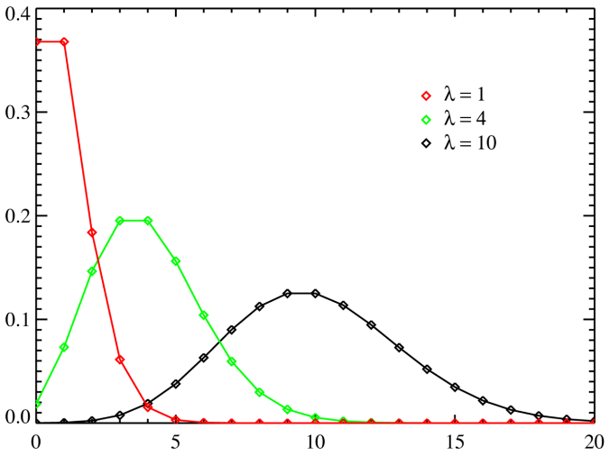

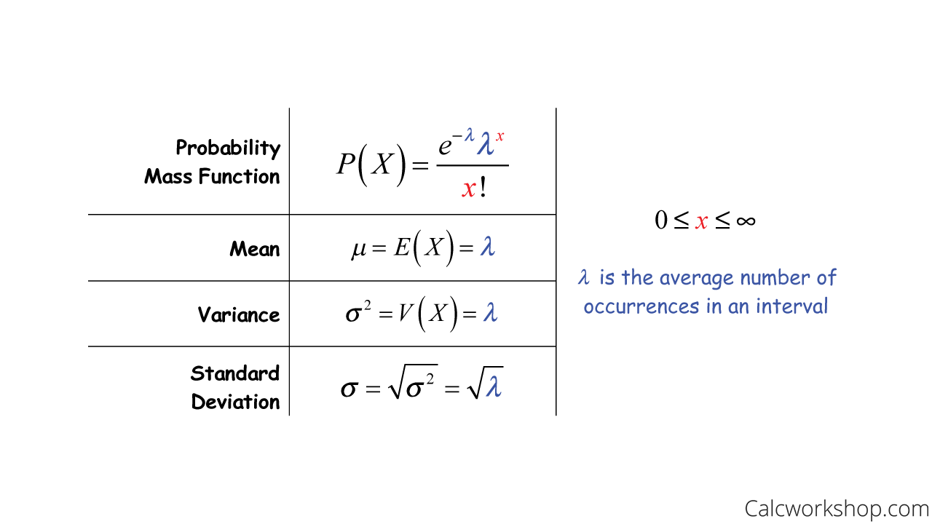

  - Evaluation:

Evaluate the fitness of each individual in the population. The fitness function quantifies how well each solution performs with respect to the optimization objective. Higher fitness indicates better solutions.
Selection:

Select individuals from the current population to serve as parents for the next generation. The selection process is biased towards individuals with higher fitness values. Common selection techniques include roulette wheel selection, tournament selection, and others.
  - Crossover (Recombination):

Take pairs of selected parents and perform crossover or recombination to create new individuals (offspring). Crossover combines genetic information from the parents, creating one or more children. Various crossover techniques, such as single-point, two-point, uniform, and others, can be used.
  - Mutation:

Introduce genetic diversity by applying mutation to some of the offspring. Mutation involves making small random changes to an individual's genetic code. Mutation helps the algorithm explore the search space more thoroughly.

  - Replacement:

Create the next generation by combining the offspring generated through crossover and mutation with the existing population. Various replacement strategies can be used, including generational replacement (replace the entire population) and steady-state replacement (replace a subset of the population).
  - Termination Criteria:

Check termination conditions. The algorithm may terminate when a maximum number of generations is reached, when a satisfactory solution is found, or based on other criteria. Termination can also be based on reaching a predefined computational budget.

- Results

Resultados e discussão (descrevendo os resultados obtidos, relacionando isso com os parâmetros utilizados e fazendo uma avaliação quantitativa e qualitativa desses resultados);

  - A Subsection Sample
Please note that the first paragraph of a section or subsection is not indented. The first paragraphs that follows a table, figure, equation etc. does not have an indent, either.
Subsequent paragraphs, however, are indented.

Sample Heading (Third Level). Only two levels of headings should be numbered. Lower level headings remain unnumbered; they are formatted as run-in headings.

Sample Heading (Forth Level). The contribution should contain no more than four levels of headings. The following Table 1 gives a summary of all heading levels.
Table 1. Table captions should be placed above the tables.
Heading level | Example | Font size and style
Title (centered) | Lecture Notes | 14 point, bold
1st-level heading | 1 Introduction | 12 point, bold
2nd-level heading | 2.1 Printing Area | 10 point, bold
3rd-level heading | Run-in Heading in Bold. Text follows | 10 point, bold
4th-level heading | Lowest Level Heading. Text follows | 10 point, italic
Displayed equations are centered and set on a separate line.
x + y = z (1)
Please try to avoid rasterized images for line-art diagrams and schemas. Whenever possible, use vector graphics instead (see Fig. 1).

Fig. 1. A figure caption is always placed below the illustration. Short captions are centered, while long ones are justified. The macro button chooses the correct format automatically.
For citations of references, we prefer the use of square brackets and consecutive numbers. Citations using labels or the author/year convention are also acceptable. The following bibliography provides a sample reference list with entries for journal articles [1], an LNCS chapter [2], a book [3], proceedings without editors [4], as well as a URL [5].

Erterter

- Conclusões
Conclusões (contendo comentários finais e indicações de como o trabalho pode ser continuado)

Podíamos elaborar uma abordagem de aprendizado por reforço em que geraríamos o time e simularíamos a batalha (sequencial, randômica ou por afinidade de atributos) e teríamos os resultados.
Seria um abordagem mais simples de implementação.

Porém optei a abordagem genética pois gostaria de simular uma evolução natural por exercitar a habilidade e que será um tipo de algoritmo que aplicarei em futuras aplicações.

References
- Bulbapedia article, https://bulbapedia.bulbagarden.net/wiki/Damage, last accessed 2023/10/20
- Author, F.: Article title. Journal 2(5), 99–110 (2016)
- Author, F., Author, S.: Title of a proceedings paper. In: Editor, F., Editor, S. (eds.) CONFERENCE 2016, LNCS, vol. 9999, pp. 1–13. Springer, Heidelberg (2016)
- Author, F., Author, S., Author, T.: Book title. 2nd edn. Publisher, Location (1999)
- Author, F.: Contribution title. In: 9th International Proceedings on Proceedings, pp. 1–2. Publisher, Location (2010)
- LNCS Homepage, http://www.springer.com/lncs, last accessed 2023/06/20

